**Experiment No :- 02**

**Name of the experiment :-** Photodegradation of methylene orange using TiO2 catalyst.

**Abastract :-** This laboratory experiment explores the photocatalytic degradation of methylene orange (MO) using titanium dioxide (TiO2) under UV light. The aim is to assess TiO2's efficiency in breaking down the dye . Degradation is monitored through UV-Vis spectroscopy to quantify dye removal over time. Results demonstrate that TiO2 significantly enhances photodegradation, with optimal conditions identified for maximum efficiency. This study underscores the potential of TiO2 photocatalysis as an effective, sustainable approach for treating wastewater contaminated with synthetic dyes. It was found that there was no degradation for the MO in the dark and in the presence of TiO2. Also no degradation was observed for MO when the solution placed under solar radiation but without TiO2.

**Keywords** :- Dye, photodegradation, irradiation, absorbance, uv-vis spectroscopy.

**Introduction :-** Methylene orange (MO) is a synthetic azo dye widely used in textiles, pharmaceuticals, and food industries. Its persistence in the environment poses significant ecological and health risks, as it can contaminate water sources and adversely affect aquatic life. Traditional methods for dye removal, such as adsorption and chemical treatments, often fall short in efficiency and sustainability. Consequently, there is growing interest in advanced oxidation processes, particularly photocatalysis, as a promising alternative for the degradation of organic pollutants.

Titanium dioxide (TiO2) has emerged as a leading photocatalyst due to its remarkable properties, including high stability, non-toxicity, and strong oxidative capabilities when activated by ultraviolet (UV) light. Under UV irradiation, TiO2 generates reactive species, such as hydroxyl radicals and superoxide anions, that can effectively decompose a wide range of organic compounds, including methylene orange. The photocatalytic degradation process involves the absorption of UV light by TiO2, resulting in the formation of electron-hole pairs. These reactive species initiate a series of chemical reactions that lead to the breakdown of the dye's molecular structure, ultimately resulting in decolorization and mineralization into harmless byproducts.

Factors such as pH, TiO2 characteristics, dye concentration, and light intensity significantly influence the efficiency of this process. Understanding these parameters is crucial for optimizing photocatalytic systems for wastewater treatment. Research continues to explore various modifications of TiO2 and alternative light sources to enhance the photocatalytic activity and reduce operational costs. By harnessing the power of TiO2 for the photodegradation of methylene orange, we can develop effective strategies for mitigating dye pollution and promoting environmental sustainability.

Theory :- The photocatalytic degradation of methylene orange (MO) using titanium dioxide (TiO2) under UV light involves several reactions. Here’s a simplified representation of the overall reaction:

1. **Excitation of TiO2**:

TiO2 + hv →TiO2 (e- + h+ )

**Formation of Reactive Species**: Generation of hydroxyl radicals:

H2​O + h+ → •OH

Formation of superoxide radicals:

O2 ​+ e− → •O2-

**Degradation of Methylene Orange**: The reaction of hydroxyl radicals with methylene orange can be simplified as:

C14​H14​N3​NaO3​S + •OH → degradation products

This typically involves breaking the azo bond (−N=N−) and resulting in smaller, less toxic organic compounds and inorganic substances.

**Overall Reaction**: A simplified overall degradation reaction can be represented as:

C14​H14​N3​NaO3​S+O2​+H2​O→ ​CO2​+H2​O+N2​+other harmless products

This representation captures the essence of the degradation process, illustrating how methylene orange is broken down into less harmful substances through the action of TiO2 under UV light.

**Aparatus and Materials :-**

1. UV machine
2. UV prove software
3. Origin software
4. TiO2
5. Methyle Orange
6. Beaker
7. Conical flusk
8. Glass rod
9. Magnetic heater
10. Magnetic bar
11. Uv light source (sunlight)
12. Distilled water

**Procedure :-**

1. Prepared 100 ml stock solution of methylene orange by dissolving a known concentration (5 mg/L) in distilled water. Stired the solution until completely dissolved.
2. 0.5 mg of TiO2 was mixed to the solution.
3. The solution was kept in the dark for 30 mins.(dye solutions)**.**
4. After that the solution collected and absorbance was measured by Uv-Vis spectroscopy. Then the solution was irradiated by sunlight with continuous stirring
5. Then the sample was collected to measure absorbance at 15 and 30 mins intervals.
6. The data was collected for the calculation of dye degradation efficiency.

**Figure :-**

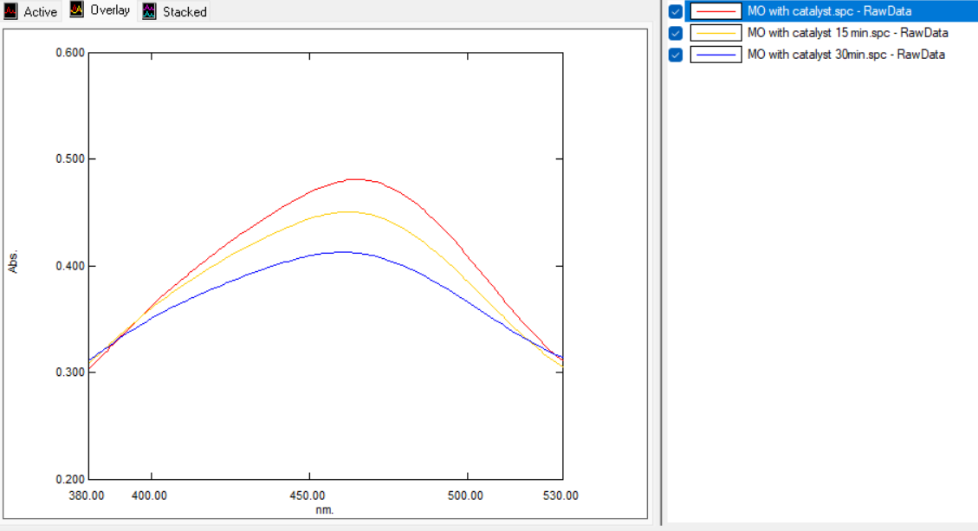

**Fig . 01.** The degradation of methyle orange using TiO2.

**Calculation :-** We know,

Degradation efficiency (%) = $\frac{(Co-Ct)}{(Co)}$*100

Where, **C**o =Initial absorbance of MO

**C**t = Absorbance at time (t)

From the graph of uv spectroscopy we get,

**C**o = 0.485 (0 min)

**C**t = 0.408 (30 min )

So, Degradation efficiency (%) **= $\frac{(0.485-0.408)}{0.485}$**  *100 %

= 15.88 %

**Discussion :-** At initial temperature MO with catalyst TiO2 soln absorbance is 0.485 .After 30 mins degradation of MO by UV light absorbance is 0.408. So, degradation efficiency is 15.88% and it’s a good amount of degradation for 4ppm MO . The degradation efficiency will be increased if the product degrade for 5-6 hours.

**Conclusion :-** The experiment demonstrated that titanium dioxide (TiO2) effectively facilitates the photocatalytic degradation of methylene orange (MO), achieving a degradation efficiency of 15.88%. While this result indicates some photocatalytic activity, it underscores the need for further optimization of parameters such as TiO2 properties, light intensity, dye concentration, and reaction time. Enhancing these factors could significantly improve degradation rates and overall efficiency. This study highlights TiO2's potential as a sustainable solution for wastewater treatment, emphasizing its role in breaking down harmful synthetic dyes and contributing to environmental remediation efforts.